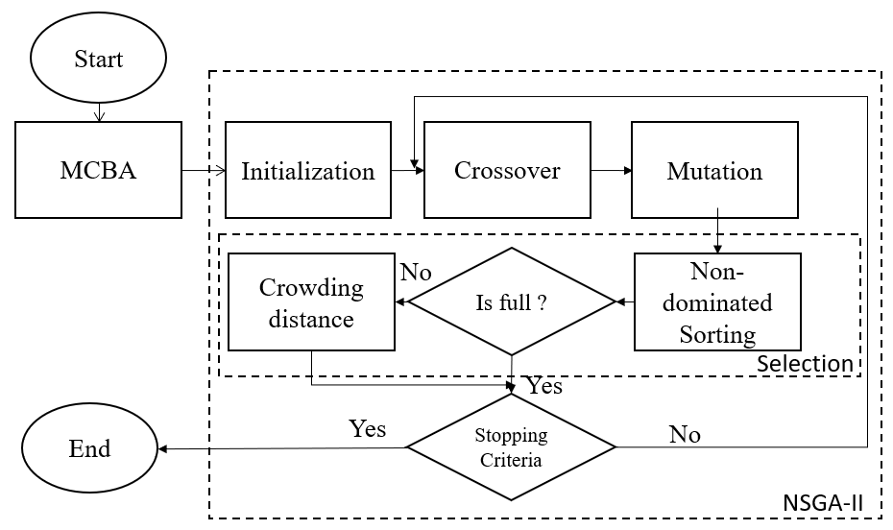

Figure 4. Flowchart of the proposed mechanism